**Hierarchy Documentation**

1. **AvatarHandler**
   1. Pedestrian
   2. Vehicles
2. **DataHandler**
3. **FadeHandler**
4. **First Person Controller**
   1. Graphics
   2. Main Camera
      1. Cylinder
      2. MenuSphere
5. **GarbageCollect**
   1. Destroy Issues
6. **Preview Cam**
   1. Background Camera
      1. Background Image
7. **RoadHandler**
8. **UI Handler**
9. **Uptown Waterloo**
   1. Buildings
   2. Road Segments
   3. Parcels
   4. OtherRoadElements
10. **Directional light**
11. **Directional light-lightmapping**
12. **Environment**
13. **Camera (Only in MainMenu and Tutorial Scene)**

Others:

1. **Browser**
2. **CursorHold**
3. **Terrain**
4. **UptownParcels**
5. **LoadingText**
6. **Parcel Walls**

Going-to-delete:

1. Sidewalks Corners and Fillers
2. Traffic Lanes

In the Hierarchy documentation, we will go through the game objects under the Hierarchy view in Unity. This document attempts to give reader a high level description of how different game objects in the IRUS project functioned and interacted with each other.

The first section of the Hierarchy documentation refers to game objects that we have worked on in the Spring 2013 work term. The second section accounts for the game objects that we have not interacted with, but we will give out a general description of their functionalities. The third section contains game objects that exist in the previous IRUS version but no usage was found during the testing process. We are going to have their components and corresponding information written down in this document, but they are going to be removed at the end of the term.

**Overview**

The IRUS project aims to provide feedback for the users in a virtual simulation environment. There is an original setting in IRUS reflecting the existing condition of the selected portion of the city; in this case, it is the King Street selection of Uptown Waterloo. Then, users are able to edit the roads, buildings information, street furniture with immediate feedback from the environment. Changes made by user will then be saved accordingly and be reloaded the next time the user login. All the data being used by IRUS is either in text format (.txt) or in comma-separated values format (.csv). They are stored under the **/Assets/Resources** folder.

Currently, the IRUS project is comprised of 3 scenes (with an extension [**.unity**]): the **MainMenu** scene (level: 0), the **Tutorial** scene (level: 1) and the **King Street_Current** scene (level: 2). In the Editor version, you can select the individual (.unity) file under **/Assets/Scenes** and run it independently, but in the Build version, (level: 0) the MainMenu scene will first be loaded. The Build settings can be adjusted under the File tab.

Once a level is loaded, scripts attached to each active game object will be run accordingly (see Documentation Preface for execution order). *Public* variables of the scripts can be edited in the **Inspector** directly. Unless specify directly in code on runtime, otherwise Unity will take the value inputted in the inspector as top priority. Thus, it is wise to declare less public variables because developer may often forget about the Inspector input to the code. However, it is extremely useful to use public variables when referencing different game objects, textures or materials in the scene because Unity has a very good User Interface to deal with it.

As mentioned in the Documentation Preface, only game objects with components mesh filter and mesh renderer will be observable in a game scene, thus most of the game objects under the Hierarchy root are not seen in runtime. The game objects that user will be able to see is under the **Uptown Waterloo** game object. Under Uptown Waterloo, there are **4** game objects: **Buildings**, **OtherRoadElements**, **Parcels** and **Road Segments**, which contains all the “physical” objects that the user will interact with in the 3D unity world.

In Unity, a static function named *Physics.Raycast* is used to detect physical game objects in the 3D world. There are either Mesh Colliders or Box Colliders attached to the children game objects of the **4** game objects mentioned above. A collider is used to give feedbacks to the *Raycast* function in runtime. The IRUS project relies heavily on these different colliders to provide information for the editors.

Every game object can have a tag attached on it to enhance sorting process. For example, when IRUS loads the street furniture from the **Resources** folder in code on runtime, developer has to attach the corresponding tag on it before compilation in Unity in order for the code to recognize it.

There are 4 cameras that developer will encounter while working on IRUS. They are the **Main Camera** under the First Person Controller, the **Preview Cam** and the **Background Camera** used by the Urban Design Editor and the **Camera** used in the Main Menu (Login) scene. They all possess different functions. The Main Camera belongs the First Person Controller and thus it is the camera users will interact with in the 3D world; the 2 preview cameras displaying the street furniture the user is going to add on the sidewalk via the Urban Design Editor; and the Camera that performs a fly-through animation in the Login scene.

We are going to start the Hierarchy Documentation by introducing the 2 editors we have been working on: the **Right Of Way Editor** and the **Urban Design Editor**.

**UI Handler**

The *UI Handler* game object contains all the Editor scripts that users might use. On start, only the *UIControl (previously written)* script is activated. The *UIControl* script handles the opening and closing of every user interface or editors in IRUS. In normal circumstance, only one editor is allowed to open. However, adjustment can be made to allow multiple UIs be opened at the same time (see Scripts-side documentation). For example, the **MovementUI**, **RotationUI** and the **ScalingUI** can be opened with the **Urban Design Editor**.

Every script can attach a specific skin on it. A GUISkin is a list of definition of how the GUI (graphic user interface – 2D objects) looks and behaves. For example, in the Right Of Way Editor skin (**ROWskin**), there are the default definitions for a *Button*, a *Label* and a *Horizontal Slider*. For every skin created, there is a **Custom Styles** attached to it. These custom styles allow developer to make specific refinements, then to be utilized in code.

In this section, we will go through the functionalities of the Right Of Way Editor and the Urban Design Editor and their corresponding scripts the **RightOfWayUI.js** and the **StreetFurnitureUI.js**.

**UI Handler – Right Of Way Editor**

The Right Of Way Editor allows user to edit the road segment. When the user first launches the editor, it prompts the user to click on any road segment.



Once the user clicks on the left mouse button, a Physics.Raycast is performed. Every game object with a Collider and with a name containing “**ROAD**” will initialize the Right Of Way Editor as below.

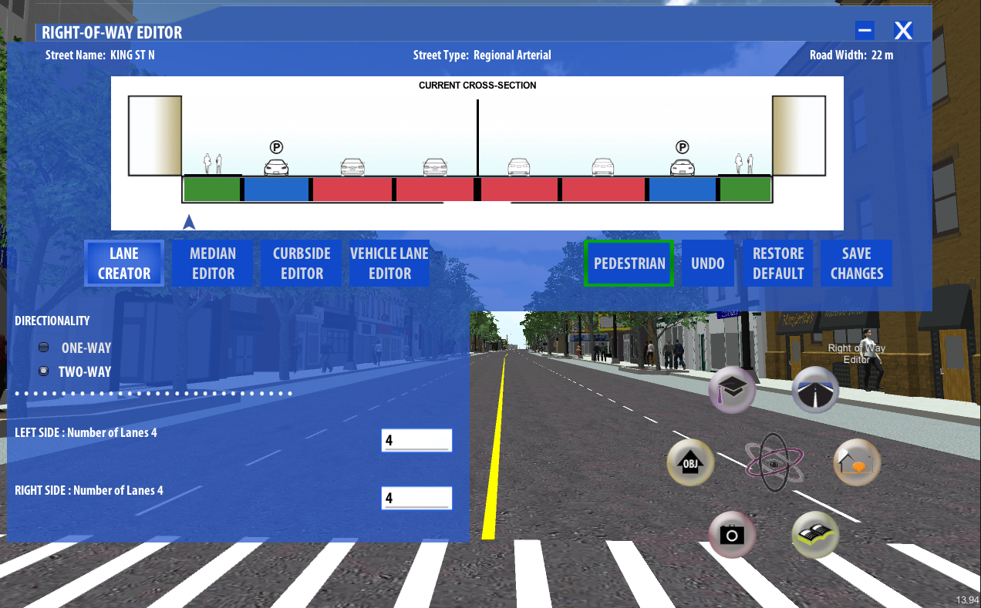

The Right Of Way Editor displays the information about the road segment selected. Every road segment game objects for the *King Street_Current* selection is under **Uptown Waterloo/Road Segments** in the Hierarchy. They all have the prefix “**7_ROAD**” for the current selection. For every road segment game objects, there is a script named “**InstantiateRoadElements.js**” attached with it. The InstantiateRoadElements script contains all the information about the road segment and more.

After the user clicks on the road segment, a copy of those information will be created in the Right Of Way Editor. The Right Of Way Editor then uses these variables to draw the cross section and display the information of the road segment. When the user adjusts the settings in the editor, only the variables in the editor is changed. Only after the changes are confirmed to be valid, they will then be uploaded to the **InstantiateRoadElements** script and be refreshed in the 3D world.

In the Spring 2013 work term, we revolutionize the cross section area so that the user can interact with it directly. The cross section area draws the different lane sections of the road segment with the corresponding types, widths and the respective color blocks. The color blocks scheme is listed below:

All traffic lanes in Red

All median elements (only for two-ways street) in Yellow

Sidewalks and Green Space in Green

Parking lanes and bike lanes in Blue

User can drag the boundary between the lane sections to adjust the respective widths. It provides immediate visual feedback to the user on the cross section area. Note that only when the user releases the drag (i.e. a mouse-up event is recorded), then the changes are registered and updated in the 3D world. Sometimes when the median is too narrow, it may not appear on the cross section. In this case, you will have to drag the arrow below to point to the center of the median, which is symbolized by the black vertical line in the cross section area.

If the road segment is not initialized for some reasons as below, the user will have to initialize it manually by adjusting the directionality and the number of segments of the road segment. Note that in order for the editor to register the text field input of the number of lanes, the user will have to hit “Enter” or the “Keypad Enter” to register the changes, and the “Save Changes” button will have to be pressed to initialize the road.

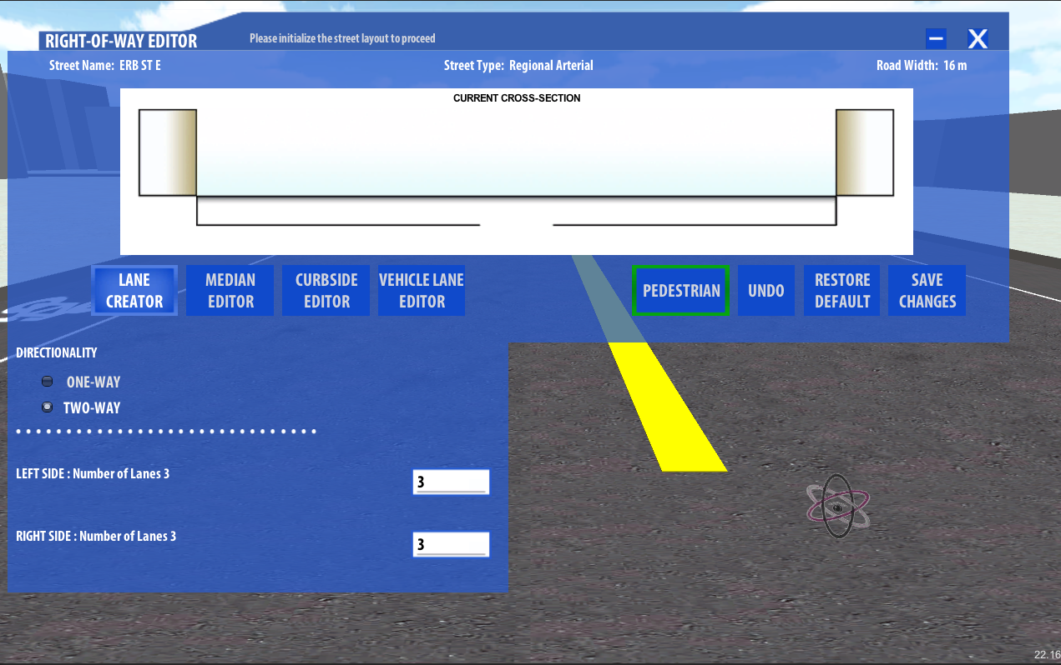

Once the road segment is initialized, user can click on the color block to adjust the settings of the particular lane section. If the user wants to change the type of the lane section, the user can click on the type editors (i.e. the **Median Editor** button, the **Curbside Editor** button and the **Vehicle Lane Editor** button) after selecting the lane section the user wishes to adjust.

There are a few restrictions are imposed on adjusting the lane sections, they are listed below:

1. The road width of the entire road segment is predefined. In addition, there are minimum widths for each lane section type. For example, the minimum width for sidewalk is 1.2 meters.
2. For a two-ways street, a curbside type is not allowed beside the median.
3. There is a predefined median for a two-ways street and only one median is allowed on a road segment.
4. In the current IRUS version, there must be sidewalks on both sides of the streets on King Street.

Next, we are going to move to the **4** function buttons of the Right Of Way Editor: **Pedestrian**, **Undo**, **Restore Default** and **Save Changes**.

**Pedestrian**

User is able to activate or deactivate the pedestrian as wishes. Once they deactivate the pedestrian, all the pedestrians in the world would be destroyed. However, the destroyed pedestrian would not reappear immediately after activating the Pedestrian. The pedestrian will only be reactivated for the road segment after changes are made. Note that Pedestrians are regenerated every time the user is modifying the road segment.

**Undo**

There is 3 sets of data exist in IRUS: the *Preset* data, the *User data* and the *Temporary data*.

The Preset data is the predefined settings being used when loading IRUS. For example, currently, there are six road segments on King Street that are already initialized with trees and flower beds on them. They are predefined parameters the developers wish the user to interact with.

The User data is the modified settings by the user during previous session.

The Temporary data keeps track of the changes the user made in the current session. That is to say there will be a brand new temporary data every time the user starts a session.

The Undo button for the Right Of Way Editor only uses the *Temporary data*.

**Restore Default**

The Restore Default button reverts the state back to the uninitialized state of the road segment. However, if there are presets for the road segments, the preset state will be used.

Note: If there is no preset for the road segment, the restore default state will automatically be saved without pressing the “Save Changes”. The reason behind this is when the user click “Save Changes”, it implies that the user wants to initialize the road with the corresponding parameters like directionality and number of lanes. Thus, it will be illogical to have the user to initialize (save changes) the road segment when the user wants to un-initialize the road segment.

**Save Changes**

As mentioned in the Undo section, there are three types of data exist in IRUS. The save changes button uses the **Temporary data** and the **User data**. The Right of Way Editor treats the temporary data as the localized change list and the user data as the global change list. When the user clicks save changes, it grabs the latest change in the temporary data and adds it to the user data.

Note: If the user closes the Right Of Way Editor without saving changes, the editor will revert the state of the road segment to the latest change in the user data (global change list).

**UI Handler – Urban Design Editor**

The Urban Design Editor allows the user to add and edit object on the sidewalk with an easy user interface. In the Spring 2013 work term, we have integrated the **EditObjectsUI** with the **StreetFurnitureUI** (i.e. the Urban Design Editor). We are going to divide this section into 2 parts: the StreetFurnitureUI and the Edit Objects UI functionality.

**StreetFurnitureUI**

There are 2 types of objects can be added on the sidewalks by the user. They are the **street furniture** and the **vegetation**. User can select the types on the side tabs.

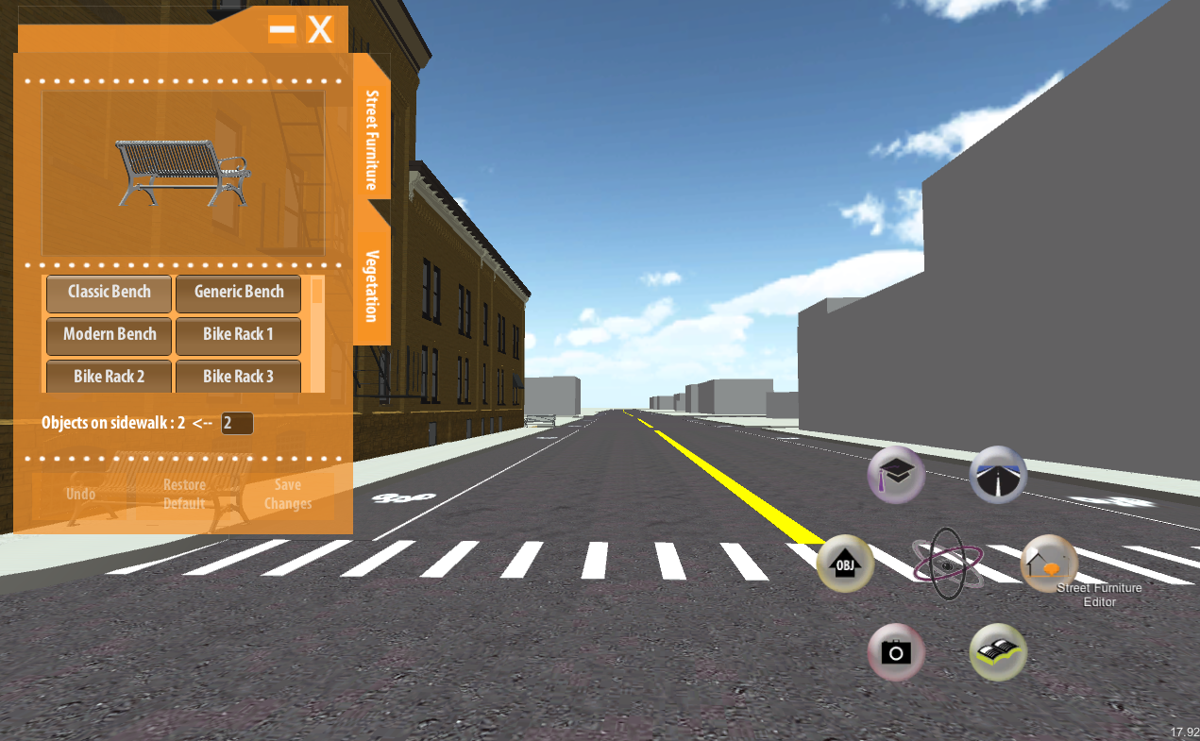

The preview camera in the editor shows a rotating object that the user is currently selecting. Under the list of available items, there is a text box to allow user to insert the number of objects needed to be instantiated on a sidewalk. Note that the editor requires the user to hit “Enter” or “Keypad Enter” to changes the value. This value must be a positive integer and its value must be between 1 and 12, otherwise the inputted value will be reverted.

After the user picks the object and inserts the number, one can click on a sidewalk to instantiate the objects. If the number of objects is greater than 1,objects with the same type that previously exist on the sidewalk will be deleted and the new objects will be placed evenly on the sidewalk. If the number of object is 1, it will add a new object on the sidewalk with the position of the mouse click.

There are **3** function buttons featured in the urban design editor: the **Undo** button, the **Restore Default** button and the **Save Changes** button. Although the names of the buttons are the same as the Right Of Way Editor, the user experience of the buttons is quite different.

**Undo**

When the undo button is clicked, a green border is lit up to indicate that the undo mode is **ON**. When the undo mode is on, the user can click on any sidewalks to revert to the previous state; at the same time, the adding objects mode of the urban design editor is turned off. User has to click on the undo button again to turn **OFF** the undo mode.

The local and global change lists concepts of the Right Of Way Editor apply to the Urban Design Editor as well.

**Restore Default**

The restore default button works similar with the undo button. When the restore default mode is ON, the green border is lit up. Then, user can click on any sidewalks to revert to the original state, which is either a blank state or the preset state.

**Save Changes**

The save changes button works the same as the Right Of Way Editor. It grabs the latest change in the local change list and appends it in the global change list. If the user closes the urban design editor without saving the changes, all of the modified sidewalks will be reverted back to the latest changes in the global change list.

**Edit Objects UI**

In the Spring 2013 work term, we have integrated the previously known EditObjectsUI with the Urban Design Editor. The Edit Objects mode is turned **ON** when an object is selected in the 3D world.

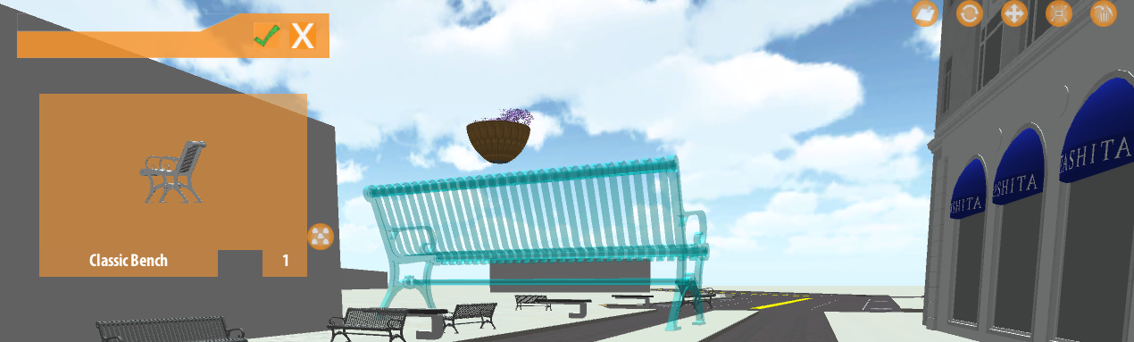

As seen from above, the urban design editor is automatically switched to the **Preview** mode and the selected object is “ghosted”.

When the Edit Objects mode is on, the preview camera will show a rotating image of the latest selected object. The type of the latest selected object is shown below as well (in this case, the selected item is “Classic Bench”). The number box on the bottom right of the preview camera is the total number of the selected objects.

**6** function buttons are introduced to the Edit Objects mode. One of them is besides the preview camera and the rest of them are on the top right corner of the screen. The one besides the preview camera is the “**Select All Type**” button and the five buttons on the corner are from left to right: **Clear Selections**, **Rotate**, **Move**, **Scale** and **Delete** buttons. The Rotate, Move and Scale buttons will open a different UI on top of the Urban Design Editor. Previous coops wrote the RotationUI, MovementUI and ScalingUI.

**Select All Type**

The Select All Type button adds all the objects of the same type of the latest selected object on the sidewalk. It is useful when user tries to move, rotate or scale objects of the same type on a sidewalk.

**Clear Selections**

Since the undo and restore default modes are forced to turn off when the edit object mode is on, even if the user deactivates the preview mode by clicking the check mark, the user still would not be able to use the function buttons. The Clear Selections button aims to clear all the selected objects from the edit objects mode.

**Rotate**

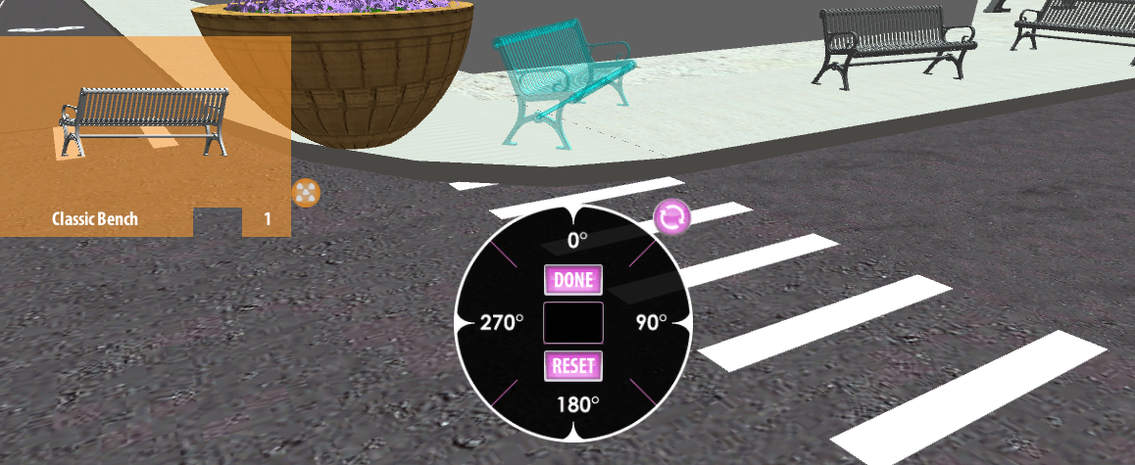

The dial of the RotationUI is used to adjust the angle of rotation of the selected objects. The angle is global which means if the user selects all the “Classic Bench” on different sidewalk and rotates all of them at the same time, they will all face to the same direction

**Move**

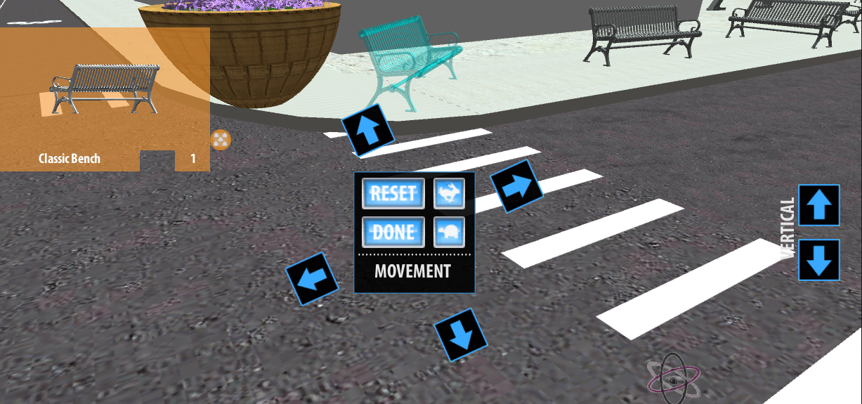

The MovementUI contains 6 directions for the user to adjust. The 4 directions arrows in the center is relative to the direction of the sidewalk and the 2 vertical directions arrows on the right is the height of the objects. The “rabbit” and the “turtle” icons in the MovementUI is the speed of the adjustment.

**Scale**

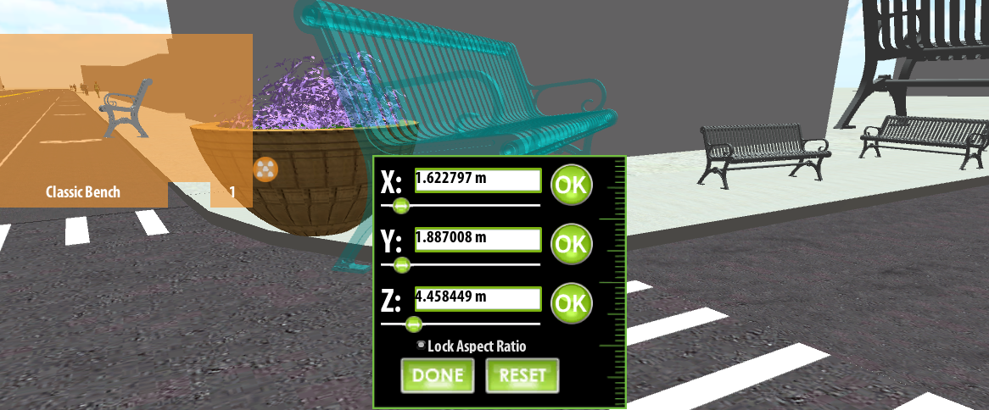

The ScalingUI allows user to adjust the scale of the selected objects by the X, Y, Z coordination of the selected objects. The checked “Lock Aspect Ratio” button allows the adjustment to change the other two correspondingly. If unchecked, only the specific coordination will be adjusted.

**Delete**

The Delete button simply destroys the selected objects on the sidewalks.

The next topic we are going to talk about is the **Preview Cam**, which is closely related to the Urban Design Editor mentioned above.

**Preview Cam**

When the Urban Design Editor is opened, the Preview Cam game object is attached with the corresponding displaying child game object (Classic Bench (Clone)).

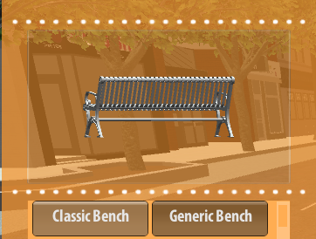 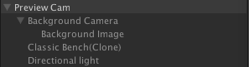

This Classic Bench (Clone) game object is what being projected by the Preview Cam. On the other hand, the **Background Image** under the **Background Camera** provides the translucent orange background of the Preview Cam.

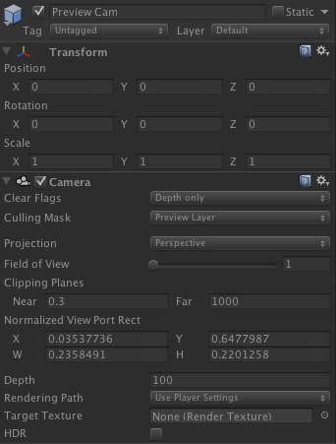 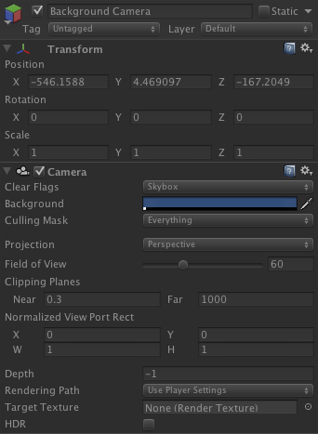

Looking at the Inspector of the Preview Cam and Background Camera (above), we can immediately grasp the concept of how the Preview Cam works. Under the **Camera** component of the both game objects, the crucial variable that allows the Background Camera to be rendered behind the Preview Cam is the **Depth** value. Cameras with a larger Depth value will be drawn on top of cameras with a smaller value.

The next variable developers may wish to adjust is the **Field of View**. The Field of View describes the view angle of the projected objects. For example, the Field of View of the Preview Cam changes the size of the selected game object in the Urban Design Editor.

Under the Background Camera, there is a **Background Image** game object. This Background Image contains a GUITexture that refers to the translucent orange background. The **Pixel Inset** variable of the Background Image game object is defined by the center of the screen. This is how the translucent orange background gets positioned.

This link shows the steps to create a background camera:

<http://answers.unity3d.com/questions/9729/how-can-i-display-a-flat-background-2d-image-not-a.html>

And this link is the Unity documentation of the Camera component:

<http://docs.unity3d.com/Documentation/Components/class-Camera.html>

Since we have already started talking about cameras, we may as well finish the remaining 2 cameras: the **Main Camera** under First Person Controller and the **Camera** in the MainMenu (Login) Scene.

**First Person Controller and Main Camera**

The First Person Controller is the “Character” that the user interacts with the 3D world. It contains different scripts to reinforce its functionality. There are also some seemingly unrelated scripts attached throughout the years, it should be reorganized at some point in the future.

Nevertheless, the First Person Controller contains Unity built-in scripts like the **Character Controller**, **MouseLook** and the **Character Motor** to give appearance and movement controls to the First Person Controller. And the showFPS script displays the frame per second on the bottom right of the screen during game play.

The **Graphics** game object under the First Person Controller gives the controller a mesh filter and renderer.

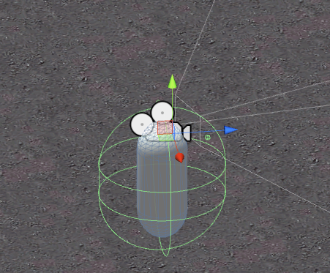

The **Main Camera** game object attached on the First Person Controller is the “eye” of the controller. It contains some scripts as well. The FirstPersonMainCamera script calls the fade in function on the start of the scene.

Under the Main Camera game object, there is a **Cylinder** game object that draws the **Pie Menu** on runtime. Note: the Pie Menu is a “physical” object in the 3D world. It is not a 2D GUI element like buttons in the Right Of Way Editor and the Urban Design Editor. The **PieMenu**.cs script adjusts the different variables of the pie menu.

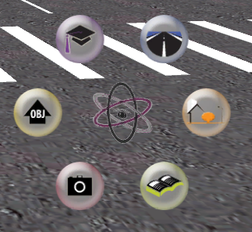

**Camera (In MainMenu.unity)**

In the Project folder, there are currently 3 scenes under the folder *Scenes*: the **King Street_Current**, **Main Menu** and the **Tutorial** scene.

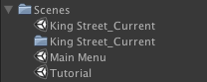

Developers can switch to different scenes by double clicking the scene.

The **Camera** game object exists only in the MainMenu and Tutorial Scene. The Camera is different than the First Person Controller Main Camera because it cannot “move”. The Camera in MainMenu performs a fly-through animation on King Street and stops at some point to show the main menu.

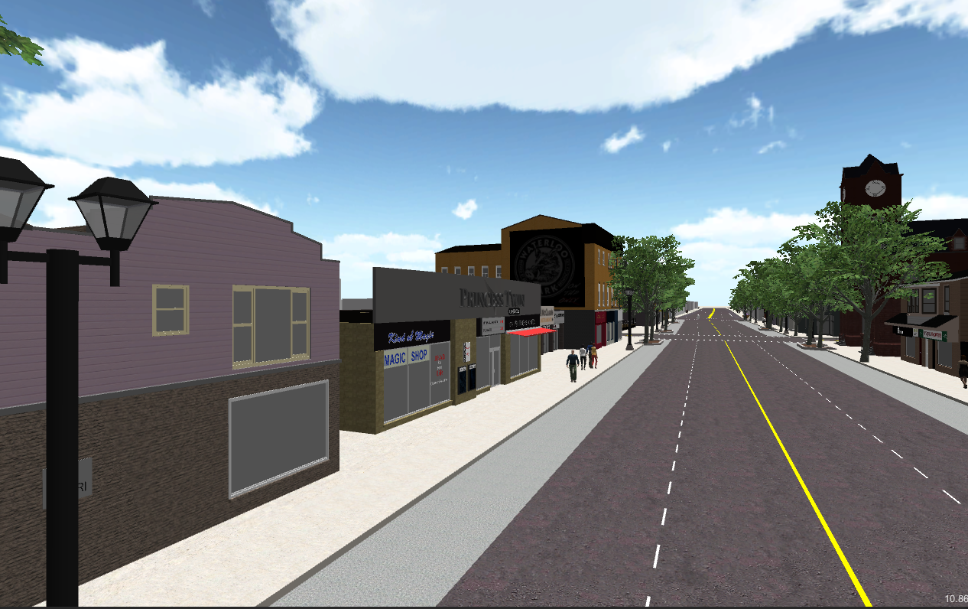 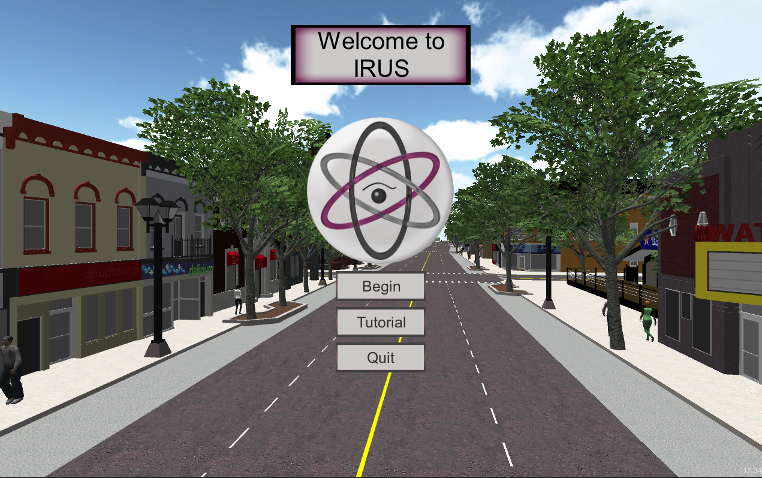

The MainMenu scene serves as an introduction scene to welcome users, thus it is defined as level 0. In a Build, level 0 will be first loaded when the application starts. Developer can drag the scenes under Build Settings (File > Build Settings… > Scenes in Build) to prioritize the levels of different scenes.

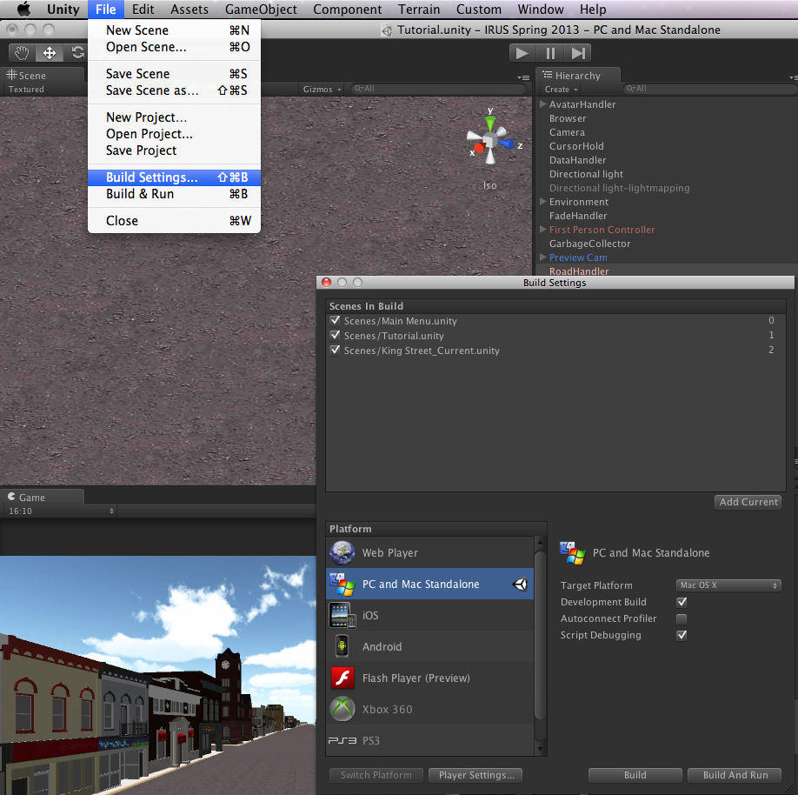

Back to the Camera game object, there is a MainMenu script attached on it to execute the fading animation, which is going to be explained in the next topic

**FadeHandler**

Currently, the FadeHandler game object exists in all scenes. It handles the fading in and out from scene to scene by the script **FadeScript** attached to it.

The FadeScript draws a texture on the screen with a changing alpha value over time to create the fading effects. The fading speed is adjusted by code for different levels. The fade texture is the only variable that can be adjusted in the Inspector because the other variables will be overwritten on runtime.

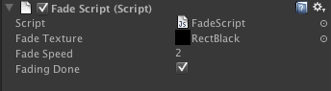

**Uptown Waterloo**

The next thing we are going to talk about is the Uptown Waterloo game object. The Uptown Waterloo contains all the “physical” objects making up the scene. There are **Buildings**, **Road Segments**, **Parcels** and **OtherRoadElements**.

Here, it is a good time for us to introduce some of the naming convention we use in IRUS. We are going to refer them as “**Unity Name**” from now on. In the Spring 2013 work term, we reimported all the fbx models for the 3 elements stated above because we need more information about the objects and a unique name. For example, a road segment object is named:

**7_ROAD_223740002_538707.67609406_-4812599.12316894_16**

There are 5 pieces of information can be extracted from this name:

The ward number, the object type, the PIN, the arc map x coordinate, the arc map y coordinate and the road width (just for road segments).

There are different scripts relied on this naming convention to distinguish between different objects. Different object types are listed below:

1. BLDG - building
2. PRCL – parcel
3. ROAD – road segment
4. INTERSECTION – road intersection
5. LOT – a block like element surrounded by roads
6. Shape – transitional shapes between road segments of different widths

In the Spring 2013 work term, we work heavily on the **Road Segments** and that is what we are going to talk about next.

**Road Segments (game object)**

The children road segment objects under Road Segments are either road segments or intersections. For the 4 game objects we mentioned above, only the Road Segments game object contains a script, which is named CreateAllRoads.js.

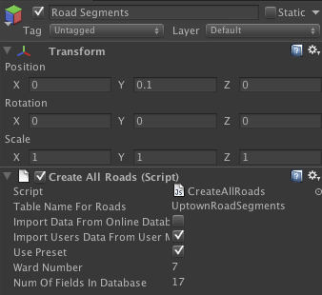

The CreateAllRoads script initializes the road segments and intersections in the 3D world and populates information for them (e.g. street name and street type) from the databases. The databases for a standalone build are under the **Resources** folder (Assets/Resources/Databases/…). For the current IRUS version, there is only one ward: **Ward_7**. Note: the naming convention of the folder is important as well, it should be *Ward_(number)* and the databases should be *Ward_(number)_Intersections.csv*and *Ward_(number)_RoadsInfo.csv*.

The public variable “**Num Of Fields In Database**” shown above for the CreateAllRoads script refers to the number of columns in the *Ward_(number)_RoadsInfo.csv*database.

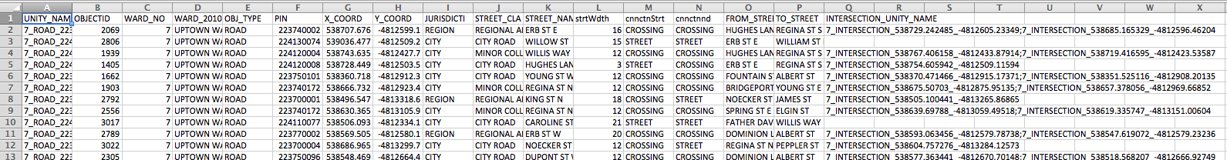

As seen from above, there are 17 columns (A to Q) in the csv database. In addition, we are using ward 7 for this IRUS version, thus the public variable “**Ward Number**” is 7 as well.

Next, the two public variables “Use Preset” and “Import Users Data From User Machine” indicate whether the preset data and user data want to be used on runtime.

Before the Spring 2013 work term, the database was retrieved from a web server. However, we have moved to the local drive database at the very beginning of the term as it reduces the run time, so the online database is outdated. For developers who wish to use the online database for any purpose, please see the documentation by the Winter 2013 Coop (**Aaron P.**). The remaining two public variables “Import Data From Online Database” and “Table Name For Roads” refer to the online database.

Now, let’s take a look at the children intersection and road objects under the Road Segment game object. The intersection and road objects are attached with the scripts **InstantiateIntersections**.js and **InstantiateRoadElements**.js respectively.

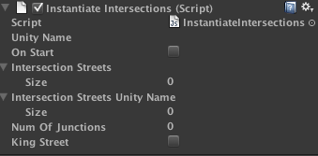 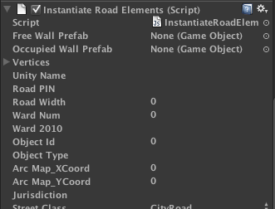

The list of (public) variables of them will be populated after the databases are processed on runtime. However, the scripts themselves have to be attached ***before compilation***.

These scripts draw the road elements and intersection on runtime.

Before running: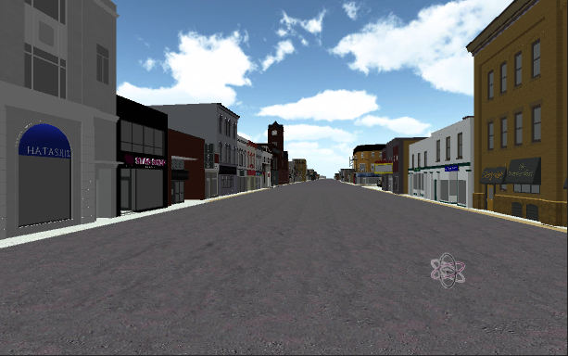

On runtime: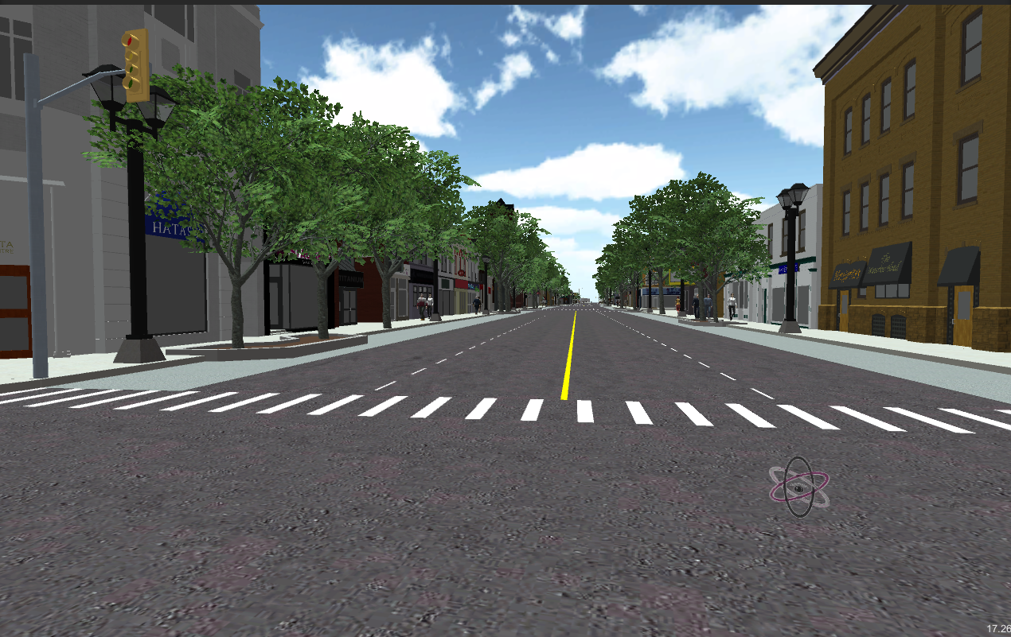

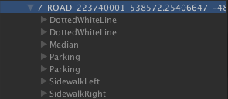 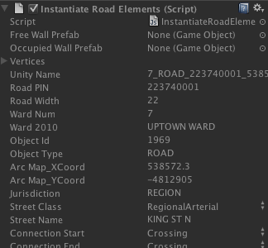

The above snapshots show that game objects are being (drawn) instantiated and the public variables are being populated on runtime. The mechanisms of how these scripts draw the road elements will be discussed on the Scripts-side documentation.

Note that, the Urban Design objects (e.g. the trees and lamp post) are under the game objects “SidewalkLeft” and “SidewalkRight”. There is no direction assigned to the roads per se because left and right is really relative to one’s perspective, but the previous coop assigned it anyways based on the longer side of the road. More detailed description will be provided in the Scripts-side documentation.

For the current IRUS version, only intersections on King Street with 4 junctions will be drawn with crosswalks.

There are Mesh Colliders attached to all the roads and the intersection for Physics.Raycast detection as well.

**The Rest: Buildings, Parcels and OtherRoadElements**

We have not really interacted much with the rest of the game objects script-wise besides reimporting all the models with a new Unity name and new coordinates. More details will be provided in the documentation by *(Jennica).

**RoadHandler**

We will move the next topic to RoadHandler, which is highly related to the Right Of Way Editor and the road segments. The original intention of the RoadHandler is unknown because of the lack of documentation. However, as IRUS progresses, the RoadHandler serves more like a communicator between the frontend and the backend; it is used in initializing roads, encoding strings to database and displaying GUI elements on the Right Of Way Editor.

The RoadHandler contains three scripts: **RoadElementsArray.js**, **RoadsBackend.js** and **RoadSegmentMain.js**. We will give an overview on these scripts in this section.

**RoadElementsArray.js**

The RoadElementsArray contains all the 2D GUI elements for the Right Of Way Editor (i.e. the textures on the cross-section area) and the 3D road element game objects (e.g. white line, yellow line and bike lane) for drawing the road segments. The RightOfWayUI, InstantiateRoadElements and InstantiateIntersections scripts will utilize this script to grab the corresponding textures or prefabs.

**RoadsBackend.js**

This script was used heavily to upload roads changes to the online web server. Since we have tried to move the functionality to the user’s local drive, this script is not being used in the current version.

**RoadSegmentMain.js**

The RoadSegmentMain serves as a communicator between the backend and the frontend. It helps initialize the road segments with the CreateAllRoads script. It helps encode and decode data string of the roads segment. It contains function to update the road segments in the 3D world with a data string. It returns textures and prefabs from RoadElementsArray with the corresponding input.

**DataHandler**

There is only one script attached to the DataHandler, it is the **UserDataBackend.js** script. This script handles all the backend information of the user’s data (from user’s local drive). It reads and writes text files to the user’s local drive. In addition, it registers a login time when the user starts the “game”.

For example, the UserDataBackend script returns a list of previous changes of the urban design object and road settings for the undo button of the Urban Design Editor and the Right Of Way Editor. It also writes the changes to the corresponding text files. In this script, the corresponding data path can also be found. More details on the mechanism of the save and load will be discussed in the Scripts-side documentation.

Here, we want to mention a script that is not belonged to the DataHandler game object but related to the entire project. This script is called the **DataParse.js**. The DataParse script is placed under the same folder as the UserDataBackend (**Assets/IRUS Scripts/Backend/…**). Because it is a static class, that is why it is not attached to any game objects in the scene. However, it helps many other scripts to parse data strings.

**AvatarHandler**

Under the Avatar Handler game object, there are **Pedestrian** and **Vehicles** game objects. In the Spring 2013 work term, we have worked only on the Pedestrian. The Pedestrian game object will contain all the pedestrian game objects on sidewalk on runtime as shown below.

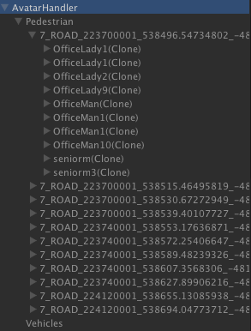

The AvatarHandler contains 2 scripts: **AvatarManager.js** and **AvatarBackend.js**. The AvatarManager manages the avatars (in the current IRUS version, the pedestrians). It controls the creation, destruction and the motion of the avatars.

On the other hand, the AvatarBackend handles the prefabs of the avatars.

In the Spring 2013 work term, we have purchased a collection of the avatars located under **/Assets/Avatars/…**. These purchases avatars provide a variety of materials. The procedure of creating the prefabs will be discuss by *(Jennica). After the prefabs are created, they can then be added to the AvatarBackend. In the current IRUS version, only the female, male and senior avatar prefabs are being populated in the AvatarBackend. They will then be randomly selected and created on the sidewalk through the AvatarManager by the InstantiateRoadElements script.

On runtime, we can see that there is a list of Unity Names under the Pedestrian game object. The full name of one of them looks something like this:

**7_ROAD_223700001_538496.54734802_-4813318.63879394_18**

They are precisely the unity name of the road segment. Each of this unity names refers to the pedestrians of that road segment. When the sidewalk of the road segment is drawn in InstantiateRoadElements, the avatars will be created in the mean time. The avatars will then be attached with a script name **Pedestrian.js** and set in motion.

An avatar must contain at least 2 components to be functional: the Animations component, which is with the purchased avatar if the prefab is created correctly, and the Pedestrian script. The Animations component contains all the motions that can be set to the avatar like walking, running, fighting and even dying, while the Pedestrian script is the AI of the avatar. It adjusts the speed and motion of the avatar. Currently, there is not collider attached on any pedestrian.

**Pedestrian.js**

For now, the Pedestrian script is just a simple AI. It contains an array called patrolLine, which specifies the lines where the pedestrian wishes to patrol back and forth. The script randomly picks a point on one of the patrol lines and has the pedestrian to move towards it. When the pedestrian arrives, it finds another point again.

We have not yet implemented the AI of the vehicles because of the complexity. If we need the vehicle to travel on a specific line and move randomly between blocks, we will need to construct a system of rules to accommodate the changing environment of the world (The streets layout are constantly changed by the Right Of Way Editor and to avoid crashing on other vehicles). We will at least have to wait until the traffic light system is done.

**GarbageCollector**

Originally, the GarbageCollector is created to deal with the delayed destruction of unity game object. According to Unity’s documentation, “Actual object destruction is always delayed until after the current Update loop, but will always be done before rendering.”. The problem with this is if we wish to create game object immediately after we destroy it with a game object holder, at some point before Unity actually destroys the game object and after we create a new game object, Unity will contain both versions of the game objects. When the actual destruction command is executed, Unity may become confused with them.

The intended purpose of the GarbageCollect is to have the intend-to-destroy game object to move under the GarbageCollector so that it would not affect flow of the code. The GarbageCollector will destroy anything under it in every Update loop.

However, we have not used the GarbageCollector because we manage to use different methods to avoid the Destroy issue.

**Generating a Build**

There are a few notes for developers when deciding to generate a build.

First, a build of IRUS contains two files: the application file(s) generated by Unity and the **Assets** folder added manually by us. Generally, the Resources folder in the Project folder is already incorporated in the application file(s) of the build version. However, we still choose to add the Assets folder with the build version for the following reasons:

1. It is more flexible for the users to add and delete files.
2. It is more flexible for the developers to update the databases and the preset data.

The Assets folder is basically a copy of the Resources folder under the Project folder.

Secondly, the build version does not allow any scripts using the Unity Editor class. There are previous coops, which have used the Editor class on some of the main features of IRUS. This will give an error when developers attempt to generate a build.

At last, for the current IRUS version, we are only generating a standalone version, which is either a Mac application or a Window .exe files. For build on other platforms like the Web Player is not available for the current IRUS version because a Web Player Build does not allow the usage of MSDN file system (which is what we use to read and write text files) for instance.